Semester 2 Project Assignment, 2026
Weekly Progress Report
Weekly Progress Report Group 8
Project Title: Heating Energy Consumption of Ice Rink
Teaching Week: 5
Date: 28/08/26
Members Attendance
Member | ID/Name/Surname | Present
1 | 21975066 Jake Pedersen | x
2 | 20937120 Bui Duc Minh Cao | x
3 | 20448350 Adam Zaltsman | x
Work Completed
Task | Description/Outcome
Clearly defining the research question | Research Question: We will be looking at building energy consumption, specifically an ice rink building where the ice surface is maintained at a fixed temperature (1 degree Celsius) and the air above a specified height is maintained at a certain temperature (T = 15 degrees Celsius) that is comfortable for customers, while determining the heat and cooling energy requirements to sustain these two conditions at a steady state.  We considered two options: a continuous 1D temperature profile, where T(z) and a lumped two-zone energy balance and are leaning towards the lumped two-zone model. The comfort zone boundary height (1.5m above the Ice) will be treated as a fixed input rather than deriving it from the model itself (like the Continuous 1D model) since our focus is on the cooling/heating energy requirements not the shape of the temperatures transition, additional it keeps the model to two coupled steady state energy balances that are solvable algebraically rather than a boundary value problem.  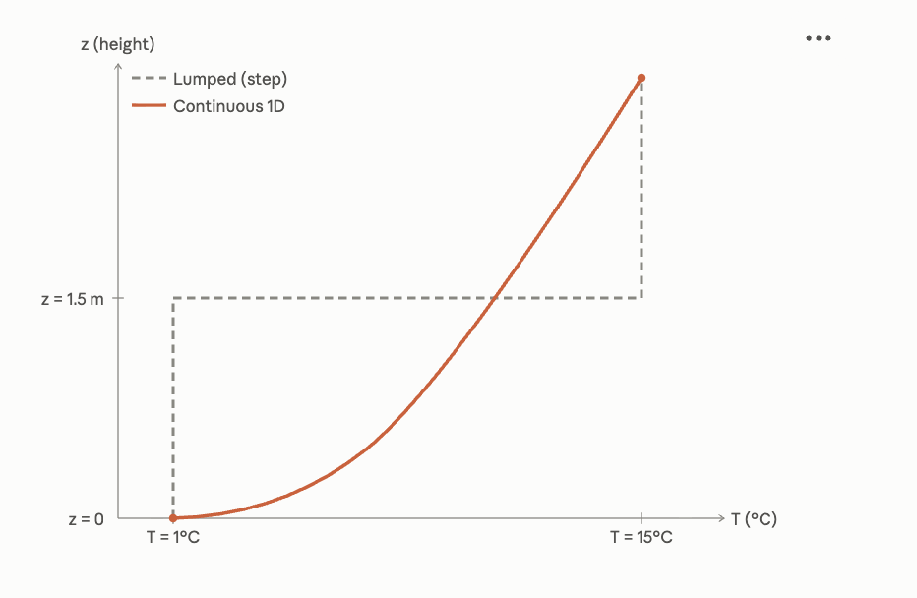
Preliminary modelling assumptions | - System conserves mass,  $\frac{DM_{sys}}{Dt}=0 or M_{sys}= \int{pdV_{sys}}$  - The building is treated as a closed system with constant air mass in each zone; no exchange with outside air is modelled.  - The system is a perfect rectangle separated into two sections: the lower ice section (below a fixed height) and the upper comfort level (above it).  - The interface height between the two zones is fixed, not derived from the model.  - Flow rates are constant  - Each zone is treated as internally uniform in temperature (fully mixed, no internal gradient)  - Steady state conditions only, no time dependence, no transient effects (resurfacing the ice, change in number of customers)  - Heat Exchange between the two zones is represented by a single lumped interzone heat transfer coefficient.  - Excludes heat loss through building envelope (walls and roof) (maybe added later as an extension depending on time and complexity)
Identification of the main variable and parameters | Independent Variables  - Lengths of the system [dx, dy, dz]  - Volume [V]
Identification of the main variable and parameters | Dependent/state Variables  - Temperature of upper system [$T_{upper}\left(t\right)$]  - Temperature of lower system [$T_{lower}(t)$]
Identification of the main variable and parameters | Parameters  - Required temperature of ice [$T_{ice}$]  - Comfortable temperature [$T_{comfort}$]
Identification of the main variable and parameters | State Variables  - Heating constant of air [$c_{air}$]  - Heating constant of ice [$c_{ice}$]  - Heating constant of concrete wall [$c_{wall}$]  - Temperature of outside system [$T_{outside}$]
Methodology | - Determine research scope and question  - Research related information for the mathematical modelling of heat exchanges  - Construct a lumped-parameter model, treating each zone as a well-mixed volume, since the quantity of interest is the total energy demand rather than its spatial distribution  - Solve the model, analytically for the steady state, and numerically in Python using the forward Euler scheme for the time-dependent case  - Verify the numerical solution against the analytical one and by refining the time step, and compare the predicted energy demand against values reported in the literature for operating ice rinks
Initial mathematical model or governing tasks | Continuity equation derived for the two-section system. Starting from the general form given in Lecture 3: $\frac{∂ρ}{∂t }+div\left(ρv\right)=0$. The incompressibility of air, which lecture 4 gives as a valid assumption for gases at low velocities, reduces it to $div\left(v\right)=0$. Integrating over each section and applying the divergence theorem yields a volume-flow balance for the ice section and the comfort level.  The continuity equation provides a volume-flow balance between the two sections: whatever air leaves one section, enters the other. Together with the incompressibility assumption and the fixed geometry, this means the air mass in each section is constant, so the thermal capacities are constant coefficients in the energy balance to be developed after Heat Transfer Modelling in chapter 6.
Prepare a clear project plan outlining the key activities and timeline. | Project plan completed, covering key activities from Week 3 to Week 14 and all submission dates. Includes division of responsibilities. Uploaded to SharePoint and version-controlled in the group's GitHub repository.  Gantt Chart (committed on GitHub):  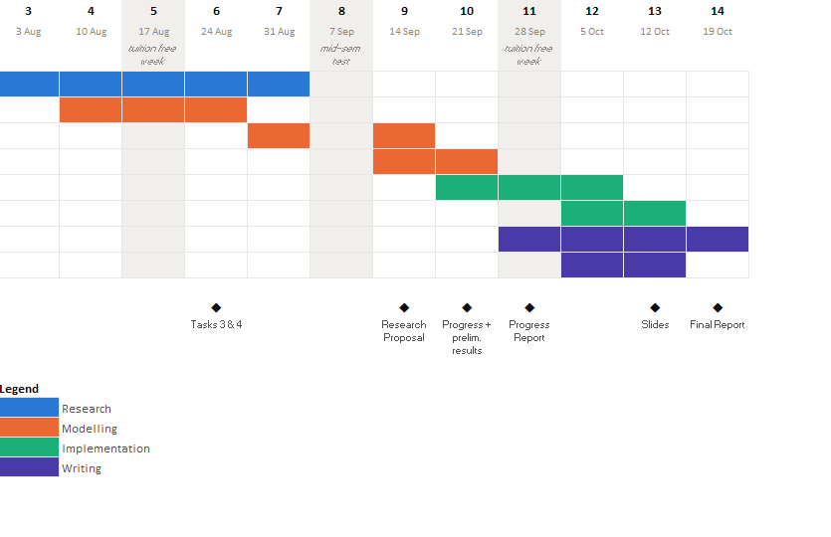
Review relevant literature related to your project topic | Adam, Cao, Jake  Air Distribution in Buildings (Khalil, E. 2013)  https://ebookcentral.proquest.com/lib/curtin/reader.action?docID=1408067&ppg=51&c=UERG  International Ice Hockey Federation, IIHF Official Rulebook 2025/26, v. 1.1 (Zurich: IIHF, 2025), 17, sec. 1.2 https://blob.iihf.com/iihf-media/iihfmvc/media/contentimages/3_the_iihf/2025-26_iihf_rulebook_22122025-v1.pdf ( ice hockey stadium size)  Lin, Wenyu, Xiaohua Liu, and Tao Zhang. 2023. "Experimental and Numerical Study of Zonal Heat and Moisture Migration inside Artificial Ice Rinks." https://www.sciencedirect.com/science/article/abs/pii/S0360132323009241  Seghouani, Lotfi, Ahmed Daoud, and Nicolas Galanis. 2009. "Prediction of Yearly Energy Requirements of Indoor Ice Rinks." https://www.sciencedirect.com/science/article/abs/pii/S0378778808002600
Individual Contributions
Member | Contribution
Jake | - Preliminary modelling assumptions  - Identification of main variables and parameters  - Review relevant literature related to your project topic
Cao | - Review relevant literature related to your project topic  - Project Plan and Gantt Chart  - Develop an initial mathematical model  - Methodology
Adam | - Researching through relevant literature  - Devised two models for representation  - Defined research question

Challenges Encountered
- Unsure whether a 1-dimensional or a lump sum model is more appropriate for the scope of the project and unit learning outcomes

Plan for Next Week
- Move progress towards the project report
- Begin developing equations for the mathematical model
- Review progress against heat exchange learning in Chapter 6

Supervisor’s Comments

